Calculus 2 Lecture 10.3: Calculus of Parametric Equations

Goal find the slope at a point on a curve that is not a function!

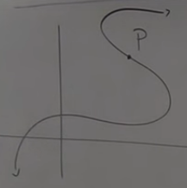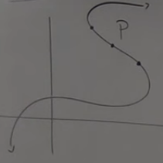

Cut the curve so that the interval around “P” becomes a function.
Suppose
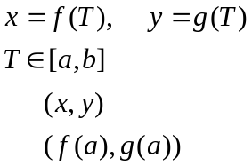

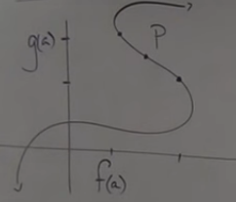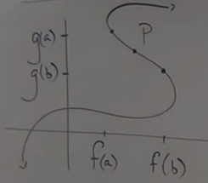

The “small section” of the curve, “the function”, we could define y as a function of x

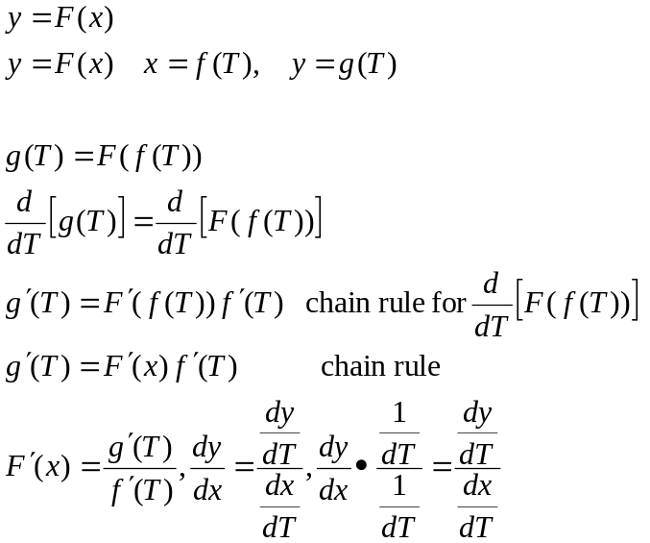
Example
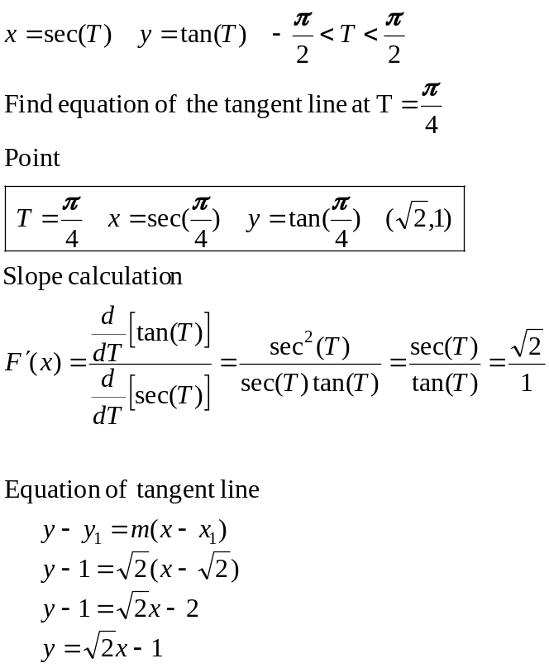

Horizontal/Vertical Tangents.
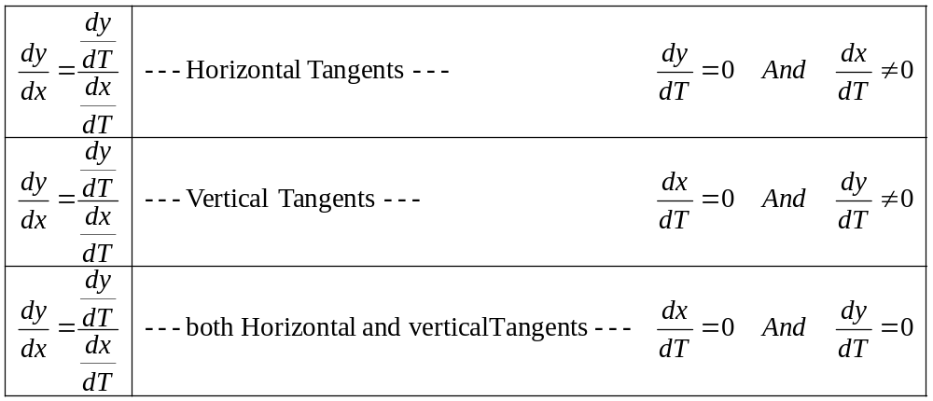

Example
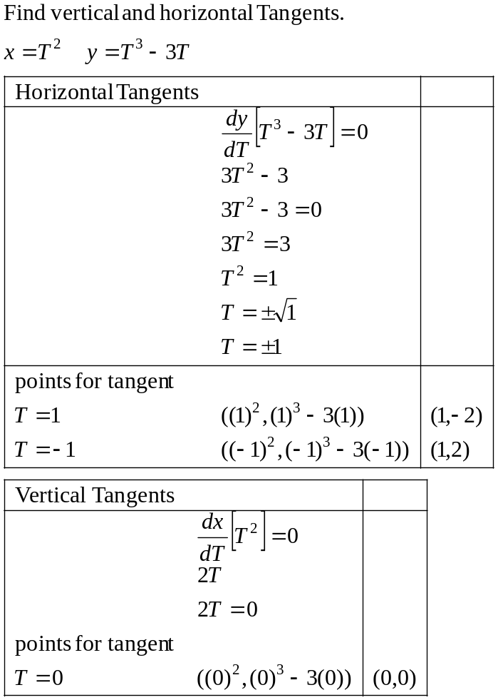
Example,continued
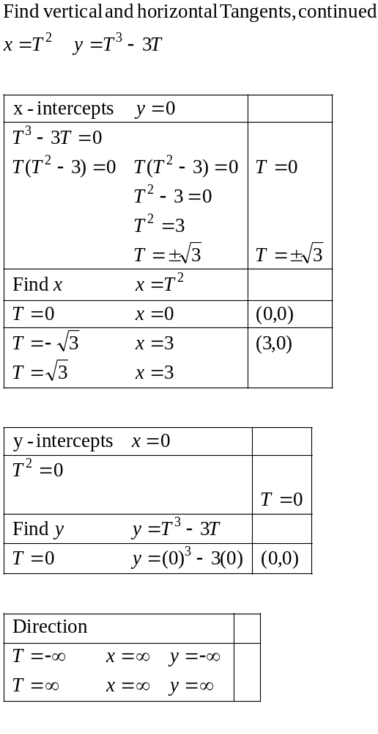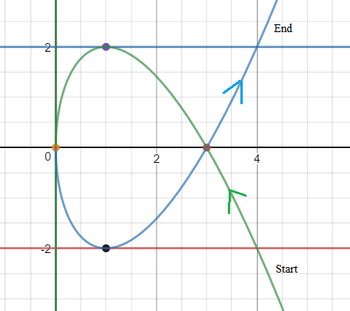

Second Derivatives:
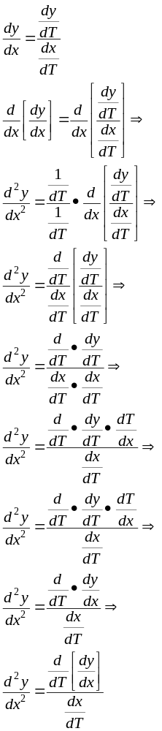

Example
Find second derivative
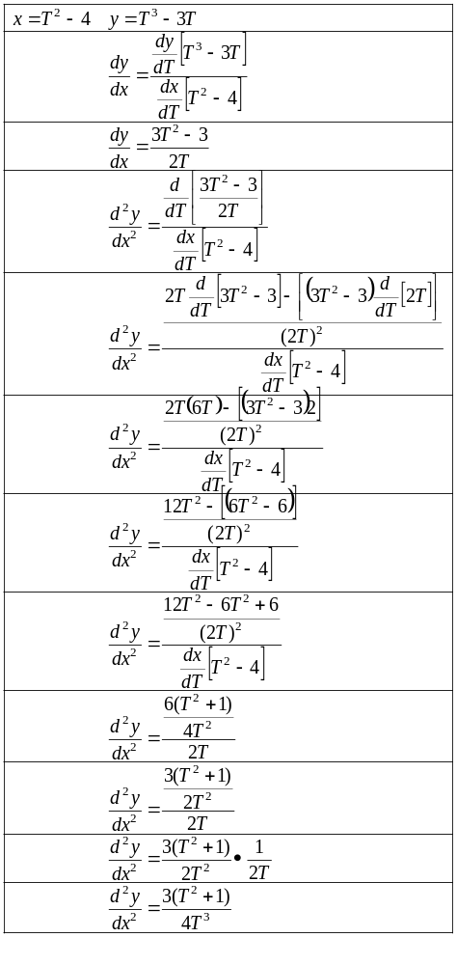

Length of a curve: 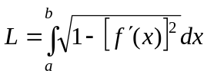
Parametrically:
Provided that the part of the curve for which you are trying to find the length is “smooth” (no gaps, no sharp points “differentiable”) and does not intersect itself (double back)

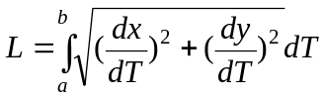

Example
Find Length of curve
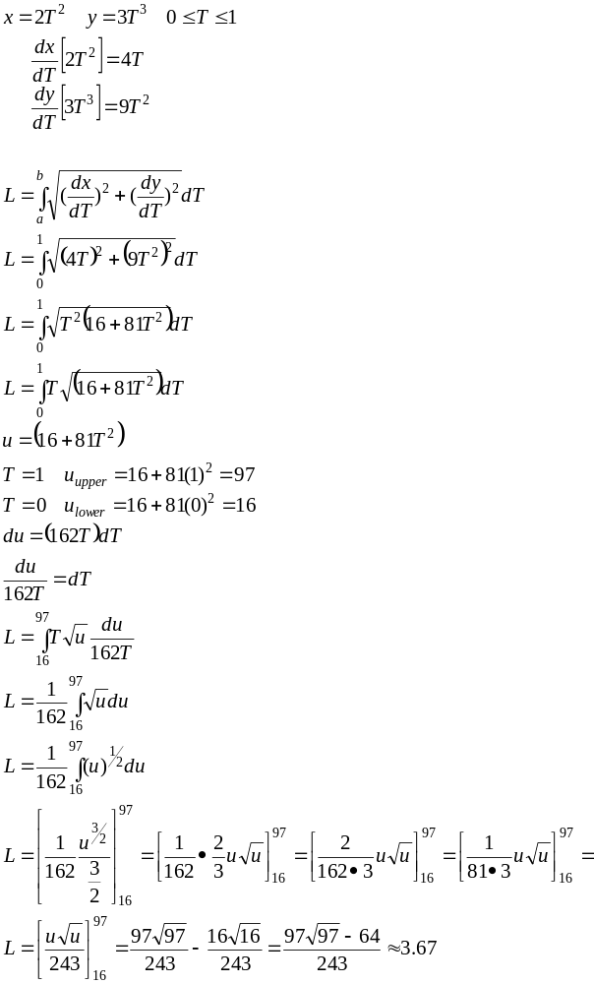
Area of a surface of revolution
Around x-axis
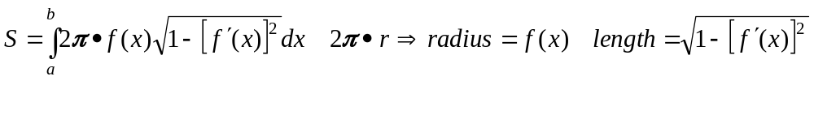
Parametrically Around x-axis

Around y-axis
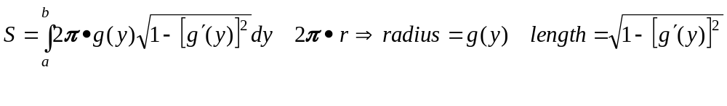
Parametrically Around y-axis

